
PROJECT REPORT
SMART SURVEILLANCE CAMERA SECURITY SYSTEM USING
RESPBERRY PI 3

POINTS HIGHLIGHT:-
- PROJECT OBJECTIVE
- PREREQUISITES AND HARDWARE SETUP
- SYSTEM CONFIGURATION (NETWORK AND CAMERA)
- SMART SURVELLIANCE FEATURE ACTIVATION
- TESTING AND DEPLOYMENT

Dr. laxmi Chaudhary (HOD)

TEAM MEMBER :- SUBMITTED TO:-
RAKESH KUMAR PANDIT (23EJIEC022) MANISH PUROHIT SIR
KARAN SINGH (24EJIEC200) AJAY KUSHWAHA SIR
(LAB TECHNICIAN)

- PROJECT OBJECTIVE:
he central objective of this project is to conceptualize, design, and implement a highly efficient, cost-effective, and intelligent surveillance camera system utilizing the Raspberry Pi single-board computer as the core processing engine. The primary aim is to move beyond the limitations of conventional, expensive CCTV hardware that typically relies on continuous recording and massive storage capacity. We seek to achieve this by integrating Internet of Things (IoT) principles and computer vision techniques (such as OpenCV). Specifically, the system must be capable of automated, real-time motion detection, minimizing unnecessary video recording and conserving energy and storage space. Upon detecting an intrusion or significant movement, the system's secondary objective is to immediately initiate recording and transmit instantaneous alerts (via email or push notifications) to the user's remote device, thereby enabling a swift and informed security response. Ultimately, this project aims to deliver a robust, scalable, and fully customizable security solution accessible to everyday users for monitoring their homes, offices, or other protected environments.

- PREREQUISITES AND HARDWARE SETUP

Item Purpose Price
1. Raspberry Pi Board The main processing unit 2800
(e.g., Pi 3B+ or Pi 3)
2. Raspberry Pi The dedicated camera 300
Camera Module for video capture
3.PIR Motion controller The detect the motion 150
of any object
4.MicroSD Card Minimum 8GB 450
space for storage (for OS) and additional
5.Power Supply Appropriate official -
model power supply for the Pi
6.Network Connection Ethernet cable or Wi-Fi access -

Total- 3700

Raspberry Pi Board
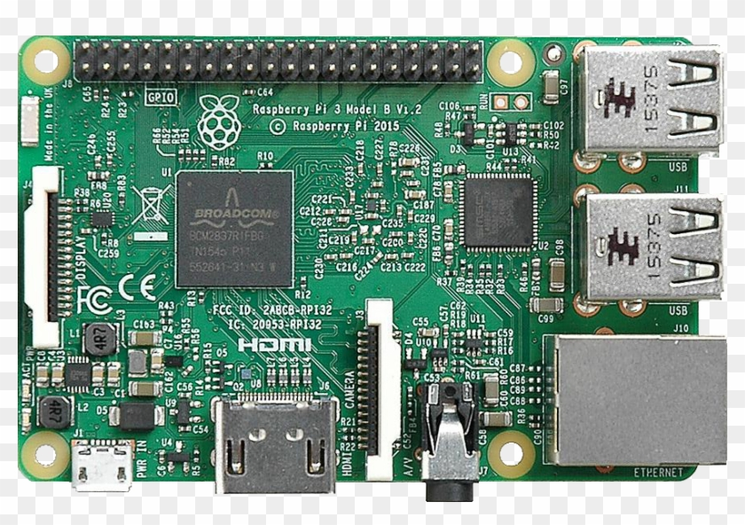

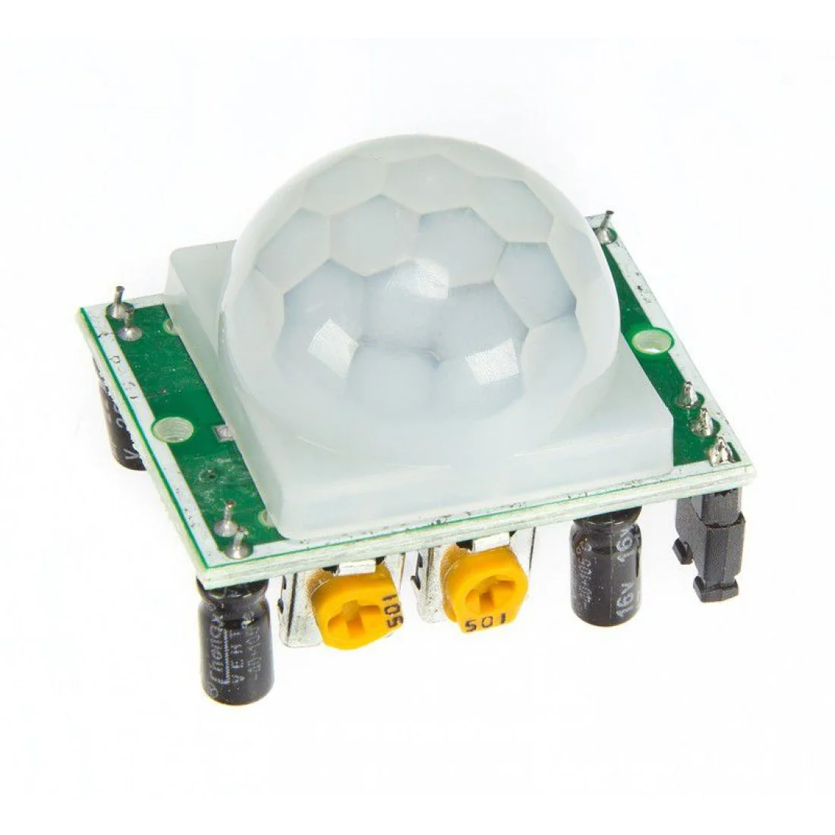
Pir Motion detector

Raspberry Pi Camera Module
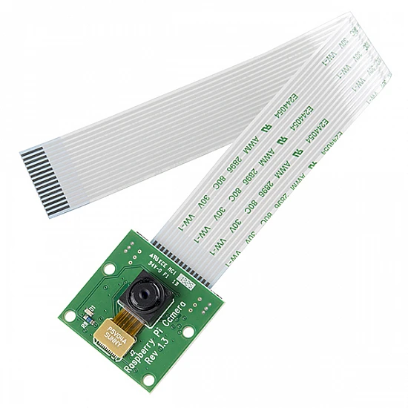

Step 1: Prepare the Software (MotionEyeOS)
Download MotionEyeOS: Download the latest image file for your specific Raspberry Pi model from the official MotionEyeOS GitHub or website.

Flash the OS: Use a utility like Raspberry Pi Imager or Balena Etcher to write the downloaded MotionEyeOS image onto the MicroSD card.

Eject Safely: Safely eject the MicroSD card from your computer once the flashing process is complete.

Step 2: Assemble the Hardware
Connect the Camera: Carefully connect the Camera Module's ribbon cable to the CSI port on the Raspberry Pi board. Ensure the cable is inserted with the silver connectors facing the camera clip/latch.

Insert MicroSD: Insert the prepared MicroSD card into the slot on the Raspberry Pi.

Power On: Connect the power supply. The Raspberry Pi will now boot up for the first time.

3. System Configuration (Network & Camera)
Step 3: Initial Boot and Network Access
First Boot: MotionEyeOS will boot and automatically configure the camera (if properly connected) and the network. This process can take several minutes.

Find the IP Address:

If using an Ethernet cable, the system is immediately connected.

You need to find the IP address assigned to the Raspberry Pi from your router's client list (or use a network scanner tool). The default hostname is often meye.

Access Web Interface: Open a web browser on your computer or phone and navigate to the IP address (e.g., http://192.168.1.100). This is the MotionEye control panel.

Step 4: Configure the Camera and Settings
Login: Log in using the default credentials (usually username admin with a blank password, or set up a new password upon first access).

Verify Feed: You should see the live video stream from the camera module.

Adjust Stream Settings: In the video device settings, configure the desired resolution and frame rate (FPS). Higher resolution means better quality but higher CPU load and storage usage.

4. Smart Surveillance Features Activation
Step 5: Activate Motion Detection
This is the core "smart" feature.

Navigate: Go to the Motion Detection settings panel for your camera.

Enable: Turn the Motion Detection switch ON.

Tune Sensitivity:

Adjust the Threshold (e.g., 2000-3000): This defines the amount of pixel change needed to trigger motion.

Adjust the Noise Level: This filters out minor visual noise to prevent false alarms.

Set Detection Area: Define specific Masks to exclude areas (like a window or a spinning fan) from triggering motion, significantly improving accuracy.

Step 6: Configure Alerts and Recording
Recording: Under File Storage, define where recorded videos (or stills) should be saved:

Local MicroSD storage.

Network Storage (SMB/FTP) for external backups.

Cloud Storage (Dropbox/Google Drive - depending on MotionEye version).

Notifications (The Alert): Go to the Notifications settings.

Set up Email Notifications by entering your SMTP server details and recipient email address.

Alternatively, set up Webhook calls to integrate with other automation services.

Action on Motion: Configure the system to perform specific actions when motion is detected, such as start recording and send an email notification.

5. Testing and Deployment
Step 7: Final Test and Hardening
Test Motion: Walk into the camera frame and verify that a recording starts and a notification is sent to your email/phone within seconds.

Security: Change the default admin password immediately.

Deployment: Place the Raspberry Pi system in its final surveillance location and ensure it has a stable power and network connection.

This completes the step-by-step implementation of the smart surveillance camera.

Would you like a brief explanation of how the Python/OpenCV method differs from this pre-built OS solution?

About this project
This project focuses on developing a Smart Surveillance Camera System using a Raspberry Pi—a small, affordable single-board computer—as the central processing unit.

Here is a brief overview of the project's purpose, components, and
functionalities:

Schematic circuit diagram

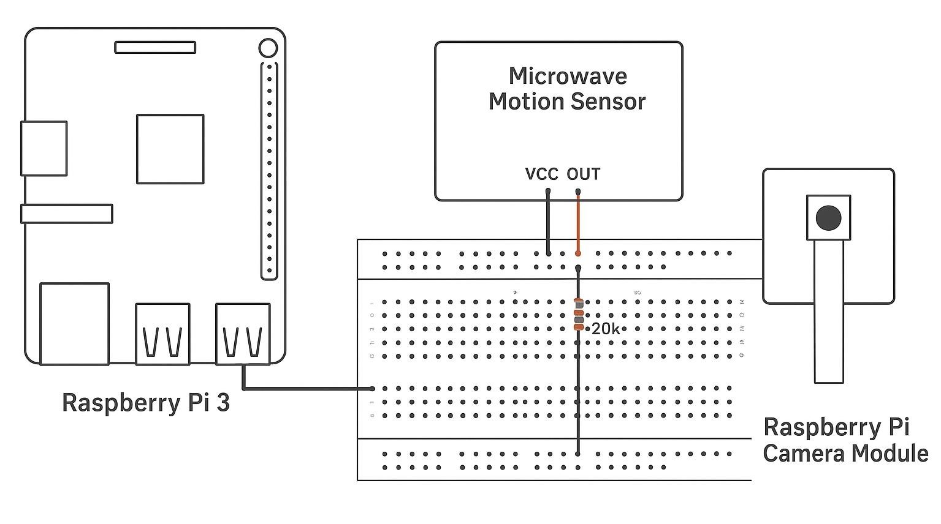
In hardware

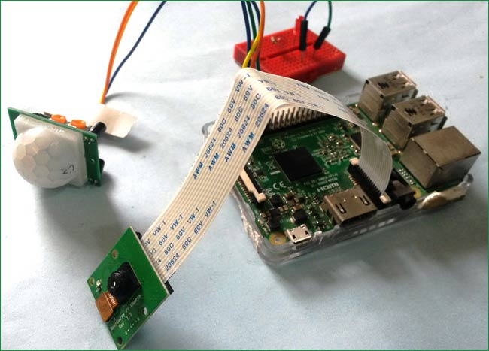

🎯 Project Overview
The goal is to create a highly customizable and cost-effective security solution that overcomes the limitations of traditional CCTV systems (which record continuously and require large storage).

Platform: Raspberry Pi (e.g., Pi 4)

Key Technology: IoT (Internet of Things) and Computer Vision.

Primary Benefit: Provides remote access and intelligent alerts.

🧩 Key Components and Tools
Hardware:

Raspberry Pi: Serves as the embedded computing device.

Camera Module (CSI or USB): Captures the video feed.

MicroSD Card: Stores the operating system and video recordings.

Software:

Operating System: Typically Raspberry Pi OS or specialized distros like MotionEyeOS.

Programming/Libraries: Python combined with the OpenCV library is commonly used for custom video processing and motion detection algorithms.

💡 Smart Functionalities
The system is considered "smart" due to its automation and remote capabilities:

Motion Detection: Instead of constantly recording, the system uses image processing (via OpenCV) to analyze the video stream and only triggers recording and alerts when it detects a change in pixels (i.e., movement).

Real-Time Notifications: When motion is detected, the system automatically sends an immediate alert via email or push notification to the user's mobile device.

Remote Monitoring: Users can access the live video feed and manage settings from any location using a web browser, thanks to the Pi's Wi-Fi/Internet connectivity.

This project essentially transforms a basic video capture setup into an automated, alert-based security system.

Would you like details on the potential advanced features (like facial recognition) that can be added using the Raspberry P

Python code
import smtplib, email, os
from email.mime.base import MIMEBase
from email.mime.multipart import MIMEMultipart
from email.mime.text import MIMEText
from email import encoders

from picamera import PiCamera
from time import sleep
from datetime import datetime
import RPi.GPIO as GPIO

#**************** GPIO setup ******************
GPIO.setwarnings(False)
GPIO.setmode(GPIO.BOARD)
GPIO.setup(11, GPIO.IN)

#**************** Email parameters ******************
subject='Security Alert: A motion has been detected'
bodyText="""\
Hi,
A motion has been detected in your room.
Please check the attachement sent from rasperry pi security system.
Regards
AS Tech-Workshop
"""
SMTP_SERVER='smtp.gmail.com'
SMTP_PORT=587
USERNAME='[SENDER_GMAIL_ADDRESS]'
PASSWORD='**********'
RECIEVER_EMAIL='[RECIEVER_GMAIL_ADDRESS]'

#**************** Video finename and path ******************
filename_part1="surveillance"
file_ext=".mp4"
now = datetime.now()
current_datetime = now.strftime("%d-%m-%Y_%H:%M:%S")
filename=filename_part1+"_"+current_datetime+file_ext
filepath="/home/pi/python_code/capture/"

def send_email():
message=MIMEMultipart()
message["From"]=USERNAME
message["To"]=RECIEVER_EMAIL
message["Subject"]=subject

message.attach(MIMEText(bodyText, 'plain'))
attachment=open(filepath+filename, "rb")

mimeBase=MIMEBase('application','octet-stream')
mimeBase.set_payload((attachment).read())

encoders.encode_base64(mimeBase)
mimeBase.add_header('Content-Disposition', "attachment; filename= " +filename)

message.attach(mimeBase)
text=message.as_string()

session=smtplib.SMTP(SMTP_SERVER, SMTP_PORT)
session.ehlo()
session.starttls()
session.ehlo()

session.login(USERNAME, PASSWORD)
session.sendmail(USERNAME, RECIEVER_EMAIL, text)
session.quit
print("Email sent")

def capture_video():
camera.start_preview()
camera.start_recording('/home/pi/python_code/capture/newvideo.h264')
camera.wait_recording(10)
camera.stop_recording()
camera.stop_preview()

def remove_file():
if os.path.exists("/home/pi/python_code/capture/newvideo.h264"):
os.remove("/home/pi/python_code/capture/newvideo.h264")
else:
print("file does not exist")

if os.path.exists(filepath+filename):
os.remove(filepath+filename)
else:
print("file does not exist")

#***************** Initiate pi Camera **************************
camera=PiCamera()

#***************** Main code for method call ************************
while True:
i = GPIO.input(11)
if i==1:
print("Motion Detected")
capture_video()
sleep(2)
res=os.system("MP4Box -add /home/pi/python_code/capture/newvideo.h264 /home/pi/python_code/capture/newvideo.mp4")
os.system("mv /home/pi/python_code/capture/newvideo.mp4 "+filepath+filename)
send_email()
sleep(2)
remove_file()

